**Name:**  GOKUL. S

**Roll Number**: 19BCS033

**U18CSI6201T - Internet and Web Programming**

**ACTIVITY – 3**

**Note.xml**

<?xml version="1.0" encoding="UTF-8"?>

<note orderid="889923" xmlns:xsi="http://www.w3.org/2001/XMLSchema-instance" xsi:noNamespaceSchemaLocation="note.xsd">

<to> Tove</to>

<from>Jani</from>

<heading>Reminder</heading>

<body>Don't forget me this weekend!</body>

</note>

**Note.xsd**

<?xml version="1.0" encoding="UTF-8"?>

<xs:schema xmlns:xs="http://www.w3.org/2001/XMLSchema" elementFormDefault="qualified">

<xs:element name="note">

<xs:complexType>

<xs:sequence>

<xs:element name="to" type="xs:string"/>

<xs:element name="from" type="xs:string"/>

<xs:element name="heading" type="xs:string"/>

<xs:element name="body" type="xs:string"/>

</xs:sequence>

</xs:complexType>

</xs:element>

</xs:schema>

**Validate the Xml and Xsd.**

While validating the above xml will throw an error because the attribute “orderid” is not specified in the xml schema.

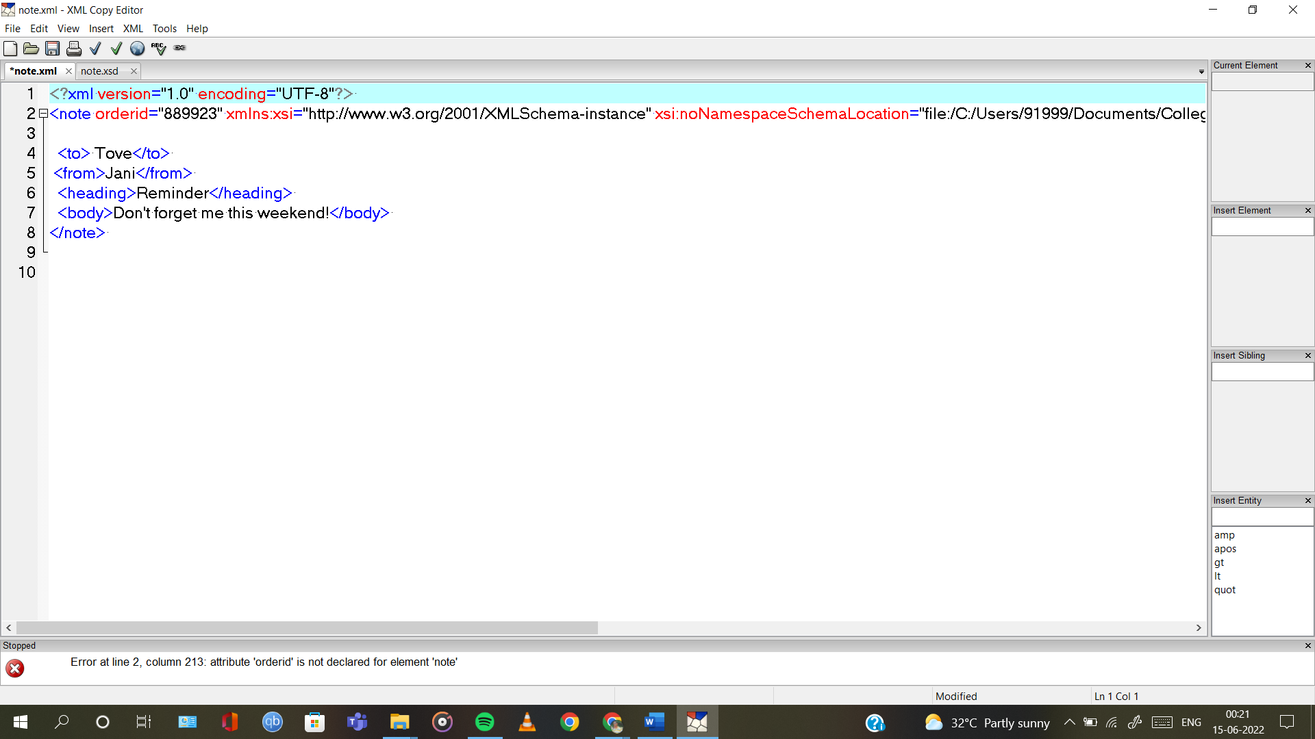



After adding the line,

<xs:attribute name="orderid" type="xs:string" use="required"/>

in the xml schema, the xml document can be validated successfully.

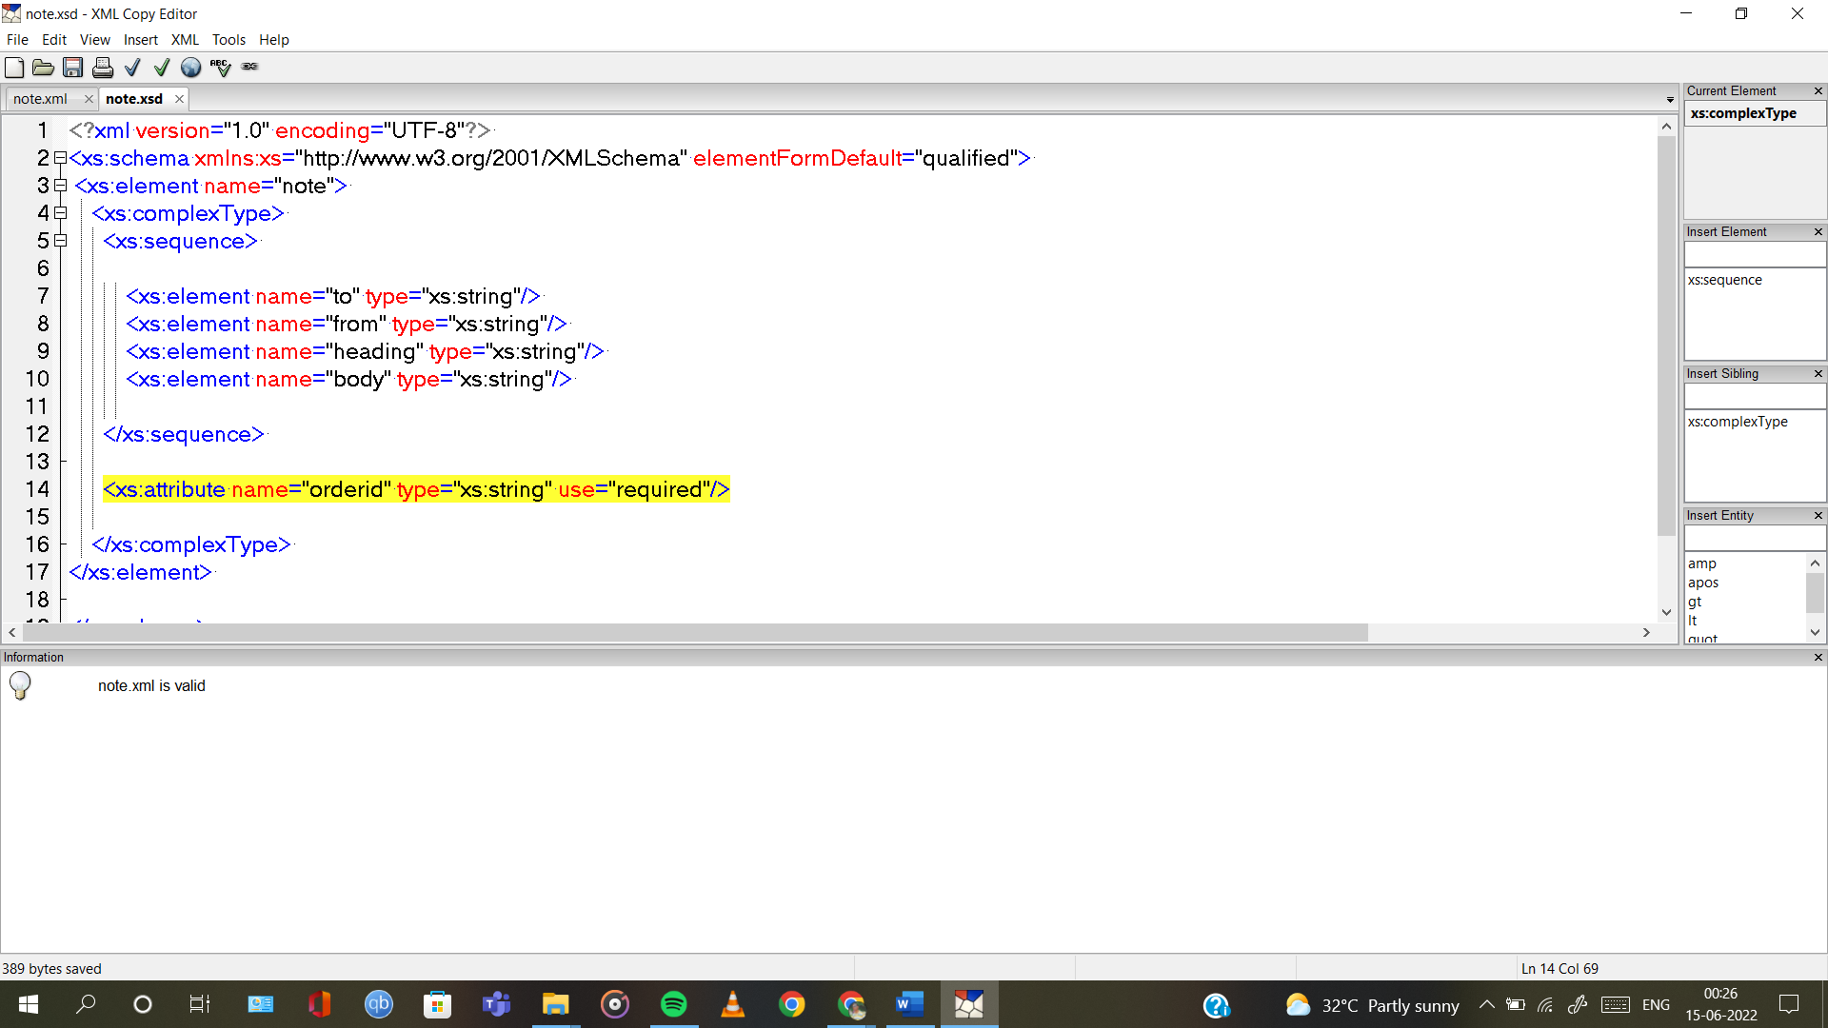



1. Employee Information using XML SCHEMA by creating employee.xml and employee.xsd

**employee.xml**

<?xml version="1.0" encoding="UTF-8"?>

<employee xmlns:xsi="http://www.w3.org/2001/XMLSchema-instance" xsi:noNamespaceSchemaLocation="employee.xsd">

<EmpName>Gokul</EmpName>

<Eid>EMP001</Eid>

<phone>1234567777</phone>

<address>

<hometown>Rajapalayam</hometown>

<state>Tamil Nadu</state>

<country>India</country>

</address>

<dateOJ>2021-03-17</dateOJ>

</employee>

**employee.xsd**

<?xml version="1.0" encoding="UTF-8"?>

<xs:schema xmlns:xs="http://www.w3.org/2001/XMLSchema" elementFormDefault="qualified">

<xs:element name="employee">

<xs:complexType>

<xs:sequence>

<xs:element name="EmpName" type="xs:string"/>

<xs:element name="Eid" type="xs:string"/>

<xs:element name="phone" type="xs:string"/>

<xs:element ref="address"/>

<xs:element name="dateOJ" type="xs:date"/>

</xs:sequence>

</xs:complexType>

</xs:element>

<xs:element name="address">

<xs:complexType>

<xs:sequence>

<xs:element name="hometown" type="xs:string"/>

<xs:element name="state" type="xs:string"/>

<xs:element name="country" type="xs:string"/>

</xs:sequence>

</xs:complexType>

</xs:element>

</xs:schema>

